Weekly Construction Progress Report – Week 20
Harrow Bay Offshore Wind · 11 May – 17 May 2026
Elena Márquez · 18 May 2026 · HB-PM-RPT-2026-W20

1. Summary
1 monopile (HB-A06) was installed this week, bringing the total to 6 of 40. The foundation campaign is on the Rev 2 baseline. Waiting on weather amounted to 14 hours.
Area | Status | Comment
Overall schedule | Green | 6/40 monopiles vs. 6 planned
Foundations | Green | TPs installed: 6
Offshore substation | Green | Fabrication / load-out
Cables | Green | Manufacturing on schedule
HSE | Green | No incidents

2. Progress
Metric | This week | Cumulative | Plan (cum.) | Variance
Monopiles installed | 1 | 6 | 6 | +0
Transition pieces installed | 1 | 6 | – | –
Waiting on weather (h) | 14 | 124 | – | –
Persons on board (avg.) | 95 | – | – | –
Man-hours MV Sea Atlas | 8,268 | 49,842 | – | –
Lost time injuries | 0 | 0 | 0 | 0
Recordable injuries | 0 | 0 | – | –
Near misses reported | 0 | 1 | – | –
HSE observation cards | 29 | – | – | –

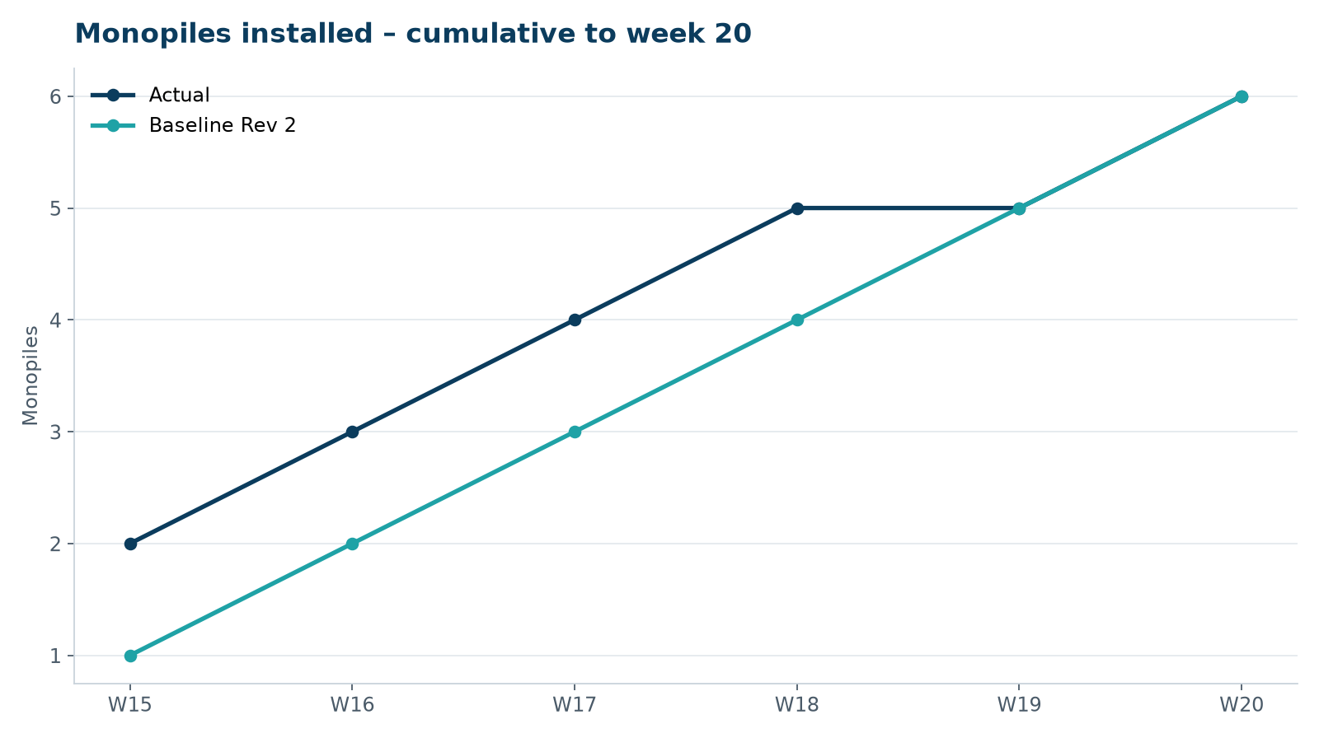
Figure 1 – Monopile installation progress, W15 to W20

3. Key activities this week
- HB-A06 installed on 12 May.
- Power purchase agreement WE-PPA-2026-004 signed with Arcturus Steel AG on 12 May (150 MW from Harrow Bay, 15 years).
- Hydrophone data review with Marlow Ecology: noise levels stable at 157–159 dB SEL.

4. Health and safety
No lost time injuries. 29 observation cards submitted; top theme: housekeeping on the main deck.

5. Environment
- HB-A06: peak 157.6 dB SEL at 750 m (compliant); pre-piling search clear, soft start on time.

6. Issues and risks
- HB-RISK-001 weather: 14 h downtime this week.

7. Look-ahead next week
Install HB-A07; Halden visit at Eastholm.
Prepared by Project Controls (Gareth Lewis); approved by Elena Márquez. Distribution: project team, Steering Committee, Halden Turbine Systems, Lenders' Technical Adviser.

